2023 NATaT Federal Platform

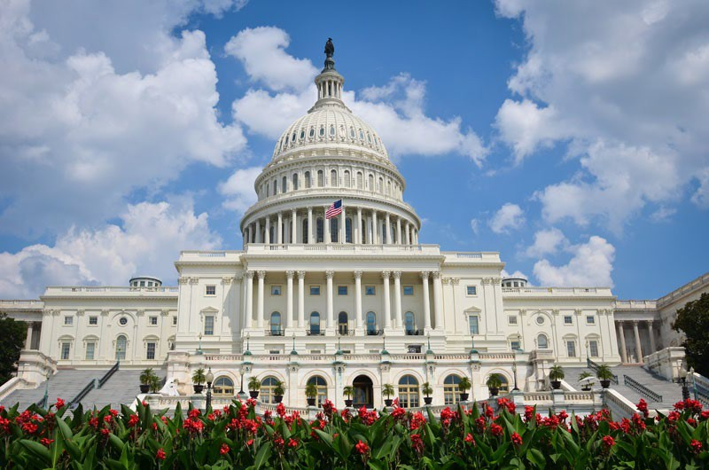

[**www.natat.org**](http://www.natat.org/)

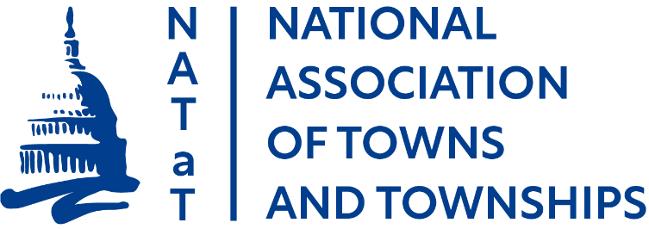

**2023 Federal Priorities**

# Infrastructure

## Transportation

* NATaT supports the U.S. Department of Transportation’s (USDOT’s) Off-System Bridge program, which funds state and local bridges that are not on the Federal-aid Highway system. However, many of the nation’s “bridges” that need repair and replacement are not eligible because they do not meet the federal definition of a bridge. Federal regulations define a bridge as a structure having a span greater than 20 feet (23 CFR 661.17(a)(1)). NATaT supports a carve-out of the off-system bridge program to include bridges that are 10 to 20 feet.
* In future authorization bills, NATaT wants to ensure that any effort to impose vehicle miles traveled fees considers the limited transportation options for rural residents and the resulting need to use their vehicles to access work and daily services.
* NATaT supports federal efforts to invest in electric vehicle (EV) infrastructure. However, we are concerned about the lack of access to this infrastructure in our more rural areas. As such, NATaT supports Congressional and Administration efforts to ensure funding for EV infrastructure is available to rural communities.
* NATaT opposes efforts to increase the national truck weight limit on the federal highway system, and efforts to allow longer, wider double- and triple-trailer trucks on federal highways.
* NATaT encourages the USDOT to prioritize funding projects in rural areas. NATaT also wants to ensure that DOT understands the reality of the current “rural” definition, which is an area that is outside an urbanized area with a population of less than 200,000. To our nation’s towns and townships, 200,000 is not “rural.”
* NATaT supports efforts to increase the federal volunteer driver mileage reimbursement (14¢/mile) to equal the federal business driver mileage reimbursement (58.5¢/mile).

## Farm Bill

NATaT supports a Rural Development Title that promotes economic growth and stability by investing in our nation’s rural infrastructure, incentivizes regional collaboration and ensures the success of our next generation of farmers. We support federal efforts to connect rural American communities, homes, farms, businesses, first responders, educational facilities, and healthcare facilities to reliable and affordable high-speed internet services.

## Telecommunications and Cybersecurity

* NATaT supports federal efforts to ensure that all locations have access to high-speed broadband with a primary focus on deployment in non-urban, rural areas where access is the most limited. Congress and the Administration should prioritize increased funding for broadband infrastructure deployment to both unserved and underserved areas and support federal programs that benefit satellite internet services that can provide universal broadband access, especially in more rural or remote areas.
* NATaT supports federal efforts to ensure coordination and planning between state and local governments that maximize the efficient and effective use of federal funds to expand broadband access in unserved and underserved rural areas. ~~NATaT supports efforts to create strong partnerships between local, state, and federal partners to maximize funds available for broadband deployment.~~
* NATaT supports federal efforts to streamline broadband infrastructure deployment *without* preempting local control over public rights-of-way, permitting, and siting processes – tenets of a community’s right to self-govern.
* NATaT supports federal efforts to reform the Universal Service Fund contribution mechanisms that will create sustainable funding for the Connect America Fund, Lifeline, Schools and Libraries, and Rural Health Care programs and ensure the availability and affordability of high-speed broadband access.
* NATaT supports federal efforts to incentivize broadband adoption including extending the Affordable Connectivity Program and creating a sustainable funding option for its long-term support.
* NATaT opposes federal efforts that restrict local governments, cooperatives, and utilities from providing broadband services.
* ~~NATaT supports federal efforts to improve broadband mapping. Current broadband maps are inadequate and do not accurately depict broadband service.~~
* NATaT supports federal efforts to improve the accuracy of the Federal Communication Commission’s National Broadband Map, including exercising Congressional oversight of the Commission’s rolling challenge process and enforcement actions levied against Internet Service Providers that provide inaccurate broadband availability data.
* NATaT supports federal efforts to provide technical assistance and funding to local governments to mitigate cybersecurity risks.
* NATaT supports the efforts of the Rural Broadband Caucus in both the House and Senate to facilitate discussion, educate Members of Congress, and develop policy solutions to close the digital divide in rural America.

# Volunteer First Responders

NATaT supports Congressional efforts to establish incentive programs to recruit and retain volunteer first responders. Volunteer firefighters alone save communities of all sizes $129 billion a year, and represent 71% of all firefighters in the U.S. Of the total number of volunteer firefighters, 95% service communities with a population of 25,000 or less.

* NATaT supports the Volunteer First Responder Housing Act that would expand existing federal housing assistance programs to qualified volunteer first responders.

# Unfunded Mandates and Federal Preemption

* NATaT strongly supports legislation that would require the federal government to provide adequate and necessary funding sufficient to implement and administer any mandate imposed on local government, including the Financial Data and Transparency Act that requires local governments that receive municipal securities to adhere to new financial data standards and put their financial information in machine-readable format. This requirement could be expanded to financial reporting in federal loan and grant programs.
* NATaT opposes federal government involvement in issues that should be resolved at the local level by elected public officials who are closest to the people affected. The federal government should limit its involvement in issues such as personnel matters, land use decisions, economic development, and delivery of local government services, and give local elected officials maximum flexibility in selecting the best options to achieve local priorities.
* NATaT supports a common-sense definition of the *“Waters of the U.S.”* rule without unnecessarily expanding the jurisdiction of the Clean Water Act.
* As mentioned in the “Broadband” section of the platform, NATaT supports preserving long-standing local zoning authorities in the deployment of emerging technologies, like small cell 5G. That authority is essential to protecting the safety of our residents.

# Census

~~According to the Census Bureau, “Legally defined county subdivisions are referred to as minor civil divisions (MCDs). MCDs are the primary divisions of a county. They comprise both governmentally functioning entities~~

~~— that is, those with elected or appointed officials who provide services and raise revenues — and nonfunctioning entities that exist primarily for administrative purposes, such as election districts.”~~

~~Twenty states have MCDs that function as general purpose governmental units. Those 20 states are divided into two categories: strong MCDs and weak MCDs. The following NATaT-member states are categorized as strong MCDs that serve as general-purpose local governments: Michigan, Minnesota, New York, Pennsylvania, and Wisconsin. The states of Illinois, North Dakota, and Ohio are classified as weak MCDs because, according to the Census Bureau, they perform less of a governmental role and are less well known locally, even though they are active governmental units.~~

~~NATaT wants the Census Bureau to reassess how it defines weak MCDs. Townships in Ohio and Illinois, for example, are general purpose governmental units that provide governmental functions including road maintenance, fire, police and EMS services, economic development, solid waste, cemeteries, parks and recreation, and senior services.~~

# 

# Federal Funding

* NATaT supports efforts to control federal spending but supports increased, or at least level funding for those federal programs that promote local economic development, create jobs, and generate tax revenues for all levels of government. They include: USDA’s Rural Development programs; FEMA’s State and Local Programs, particularly Fire Act Grants; Economic Development Administration programs; and National Telecommunications and Information Administration broadband-related programs.
* NATaT supports budget allocation policies that are fair to towns and townships. A disproportionate amount of federal funds is directed to larger metropolitan communities. Notably, larger communities have significant needs, but so do our nation’s smaller communities. Allowing smaller local governments to access funding directly, and in the same manner as large municipalities, will enhance job creation and economic development in communities throughout the country. NATaT supports direct funding for ALL units of local government as included in the American Rescue Plan Act (ARPA) (P.L. No. 117-2).
* NATaT opposes any Congressional effort to claw back ARPA funds that have not yet been obligated or spent by state and local recipients. Many towns and townships that received these funds waited to obligate or spend these funds until they had clear guidance from the U.S. Treasury, which took months to finalize. These recipients are making thoughtful, informed decisions on how to best spend these recovery funds.

# Tax

* NATaT supports preserving the tax-exempt status of municipal bonds that have helped build public infrastructure for more than 200 years. These bonds enable state and local governments to access necessary capital for critical infrastructure projects. NATaT also supports reinstating advance refunding bonds to allow a community to refinance a municipal bond and maintain the bond’s tax-exempt status.
* NATaT supports the efforts of the House Municipal Finance Caucus as a forum to discuss the opportunities and challenges for local governments to fund initiatives that strengthen our communities, and to advocate for bipartisan policies that enhance our access to the capital markets.



[**www.natat.org**](http://www.natat.org/)

**For more information, contact NATaT Federal Director Jennifer Imo at** [**202.454.3947/jimo@tfgnet.com**](mailto:202.454.3947/jimo@tfgnet.com)

[**www.natat.org**](http://www.natat.org/)

**For more information, contact NATaT Federal Director Jennifer Imo at** [**202.454.3947/jimo@tfgnet.com**](mailto:202.454.3947/jimo@tfgnet.com)

The National Association of Towns and Townships (NATaT) is the voice for more than 10,000 towns and townships across the country seeking to enhance the ability of smaller communities to deliver public services, economic vitality, and good government to their citizens. America’s towns and townships seek to partner with the federal government to ensure that public laws, policies, regulations, and resources support our role in fostering local democracy.

There are approximately 39,000 units of local government in the United States. Of that number, 85 percent serve communities with less than 10,000 people and nearly half have fewer than 1,000 residents. Approximately one quarter of all Americans live in rural areas, roughly the same percentage as live in central cities. NATaT was formed more than 40 years ago to provide those smaller communities a strong voice in Washington, D.C. NATaT’s purpose today, as it was then, is to champion pro-town and -township federal initiatives and to promote legislative and regulatory policies designed to strengthen smaller units of local government.

NATaT has developed a proactive federal agenda to ensure that the needs and interests of the nation’s smaller communities are reflected in all major federal statutory, regulatory, funding, and policy decisions made in Washington. NATaT is eager to work in collaboration with the other local government associations, the Administration, and Congress to achieve these goals.

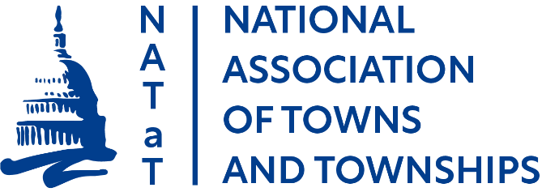**NATaT members include town and township officials represented by the following state associations:**

Township Officials of Illinois Michigan Townships Association Minnesota Association of Townships

Association of Towns of the State of New York North Dakota Township Officers Association Ohio Township Association

Pennsylvania State Association of Township Supervisors Wisconsin Towns Association